# COMPETENCY PROFILE

**OF**

**CORRECTIONAL OFFICER**

## Sponsored by

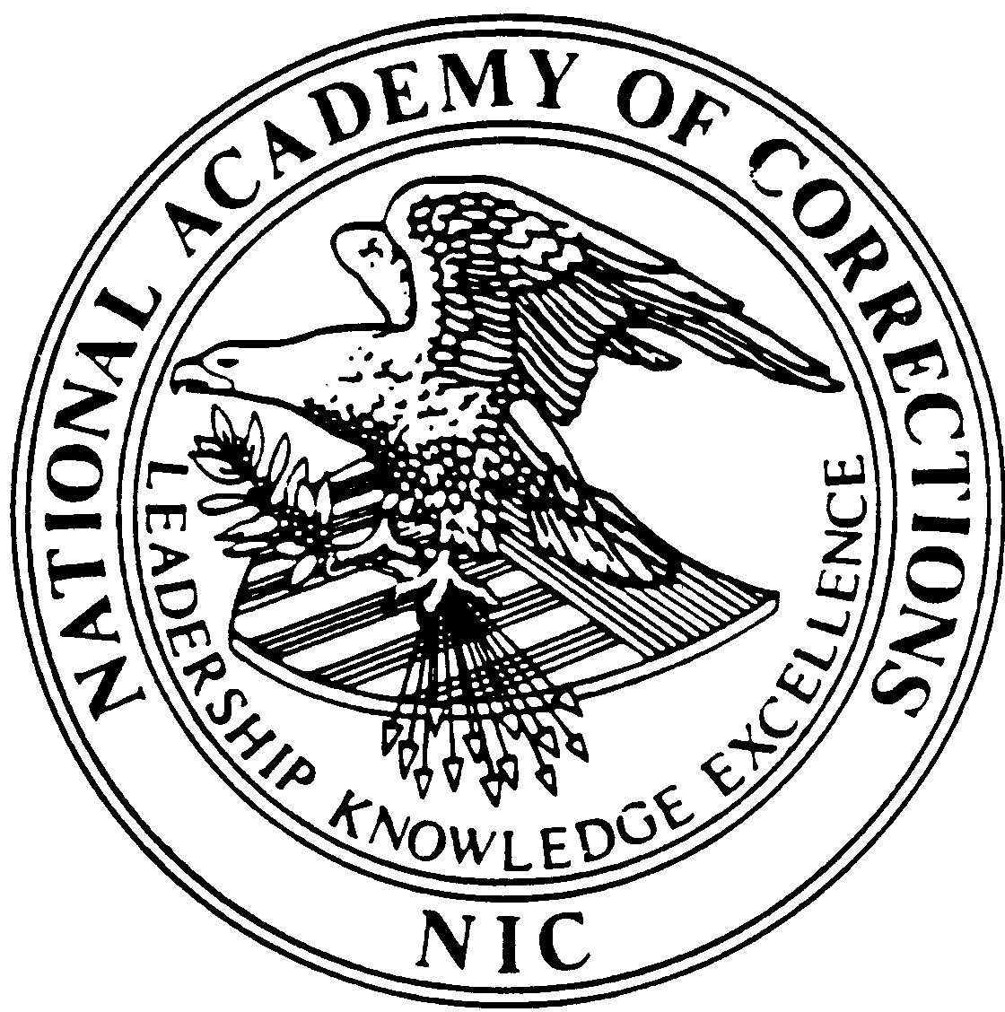

**U.S. DEPARTMENT OF JUSTICE**

National Institute of Corrections

**June, 1992**

## CORRECTIONAL OFFICER

...**ensures the public safety by providing for the care, custody, control, and maintenance of inmates**

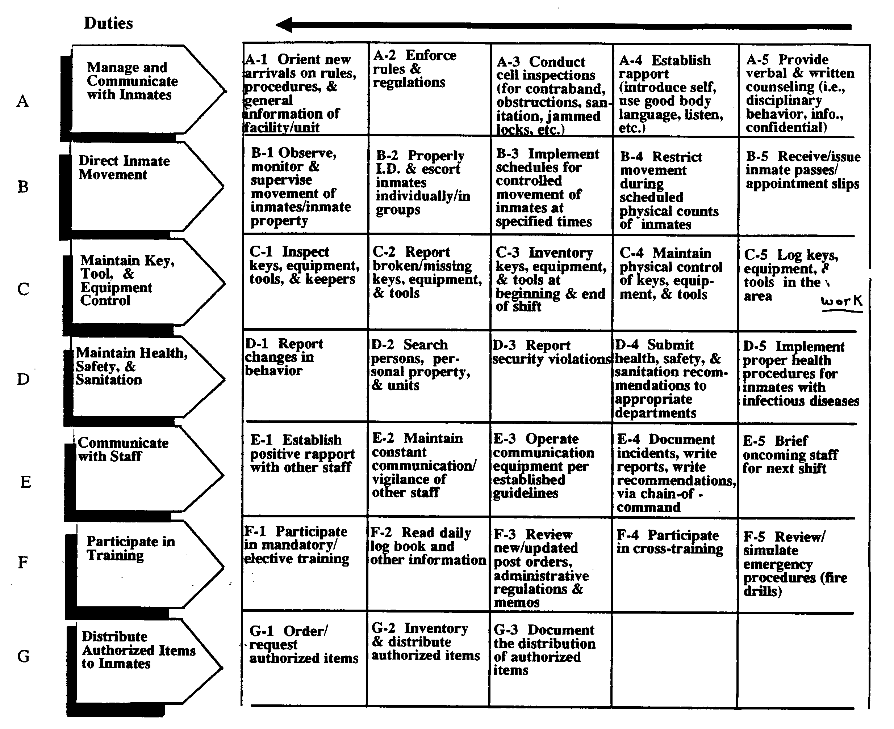

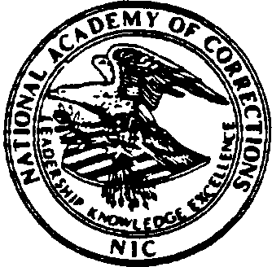**June 1992 Longmont, Colorado**

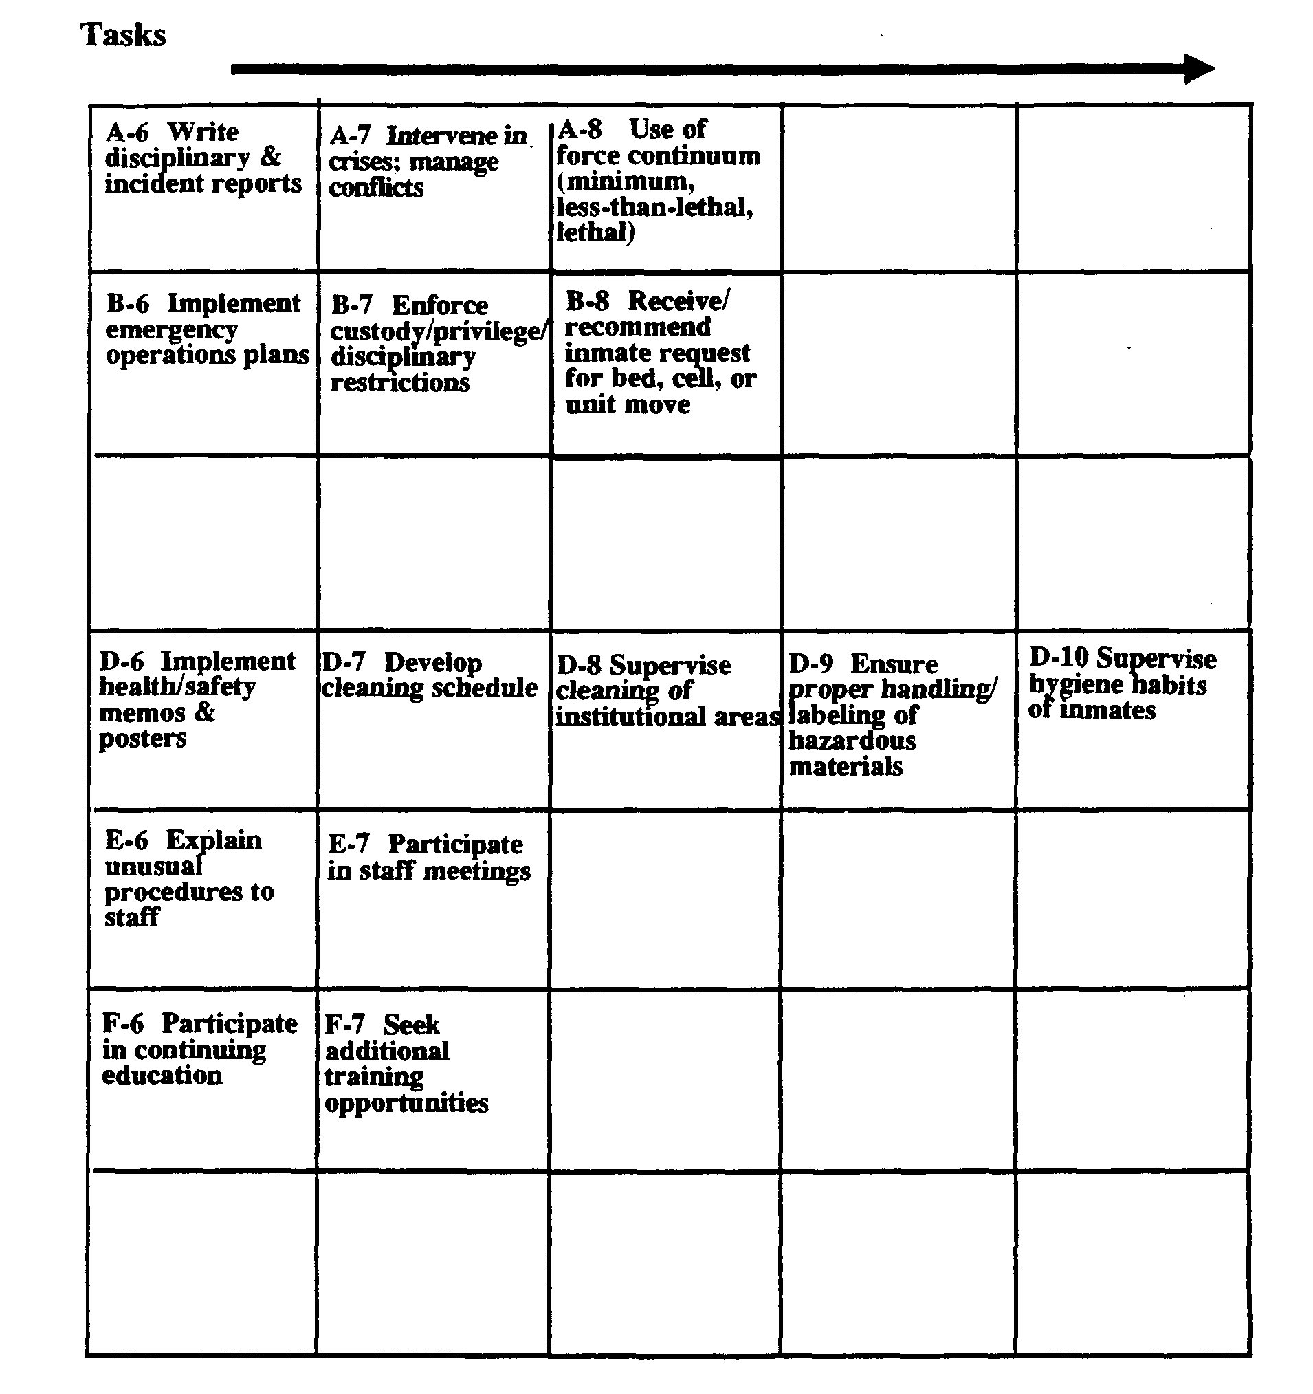

## Traits&Attitudes



ProfessionalDependableConsistent Fair

Emotionally stable

EmpathicEthical Flexible Punctual

Self-motivated Cooperative

Sincere

Sense of humor optimistic Perceptive

CompassionateAnalytical

Leader Assertive

## Knowledge &Skills

### Knowledge of:

State laws

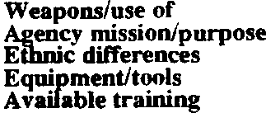Policies & procedures Force/use of

Stress management

### Skillsin:

Written communication

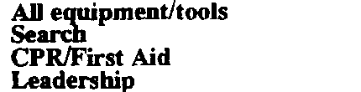Non-verbal communication

Public relations Management

Interpersonal communication

## Tools&Equipment

**CORRECTIONALOFFICER**

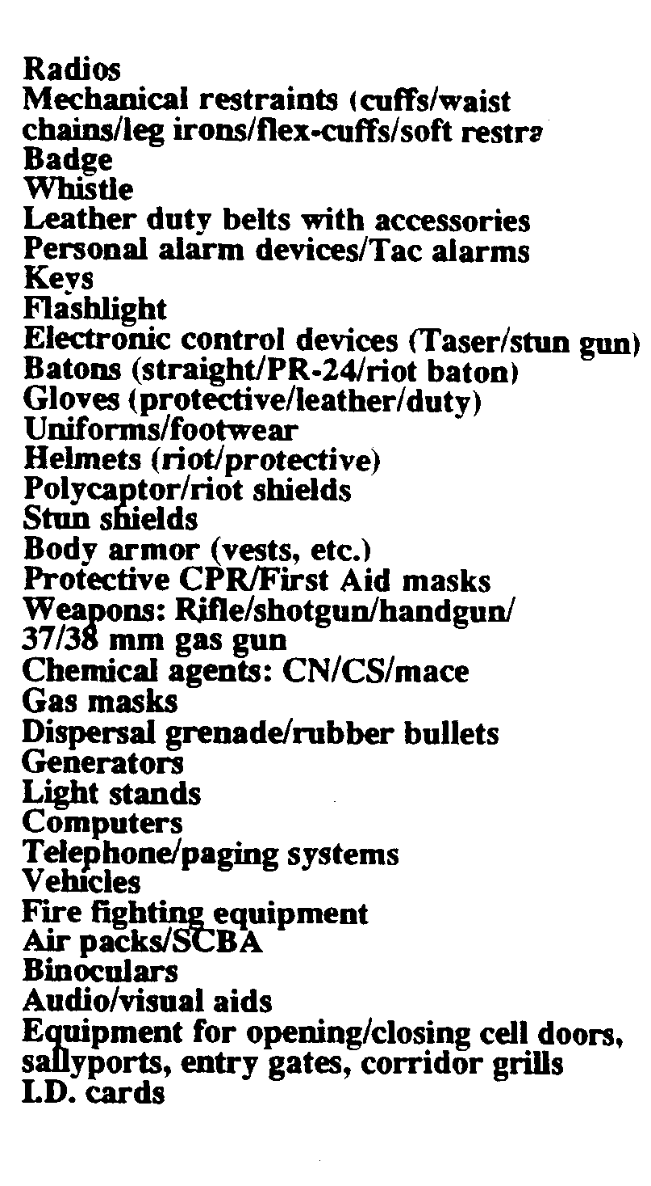

**Panel Members**

**DACUM Facilitators from the**

**National Academy of Corrections:**

Gordon Chapman

#### Correctional Officer

PADOC Training Academy 1451 Market Street

Elizabeth, PA 17022-1299

Richard Fisher

#### Correctional Officer

Buena Vista Correctional Facility

P.O.Box 2017

BuenaVista, CO 81211

**Sherry Honea** Correctional Officer Ellis Iiunit Huntville, TX 77340

**Pedro Mata, Jr.** Correctional Officer Joliet Correctional Center

#### P.O. Box 515

Joliet, IL 60432

Charles Sofko

#### Correctional Officer

**Perry** Correctional Institution 430 Oaklawn Road

Pelzer, SC 29669

**Michael Stephen** Correctional Officer Pelican Bay State Prison 5905 Lake Earl Drive

#### P.O. Box 7000

Cresent City, CA 95531

Theresa Sanders Correctional Officer

Ionia **Maximum Correctional** Facility

#### 1576 West Bluewater Highway Ionia, MI 48846

**IdaHalasz, Ph.D.MaryFlannigan, Ed.D.**

**Dianne Carter, Ed.D. President**

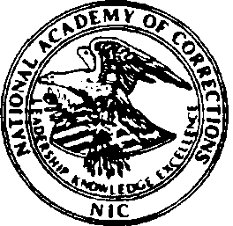**National Academy of Corrections**

***Graphics Composition by Charlotte Bentley (National Academy of Corrections)***

**US: Department of Justice National Institute of Corrections**